ADITHYA R
192311369
Question:
Create a simple cloud software application for Flight Reservation System using any Cloud Service Provider to demonstrate SaaS.
AIM: To design and implement a Flight Reservation System as a cloud-based SaaS application using Zoho Creator.
PROCEDURE:
* Log in to Zoho Creator and create a new application from scratch.
* Create a Flight Details form to store flight information such as source, destination, time, and fare.
* Create a Passenger Details form to store passenger personal information.
* Create a Reservation / Booking Details form and add lookup fields to connect passengers and flights.
* Configure basic workflows to update booking status automatically.
* Publish the application and enable cloud access for users.
* The software has been created.

IMPLEMENTATION:
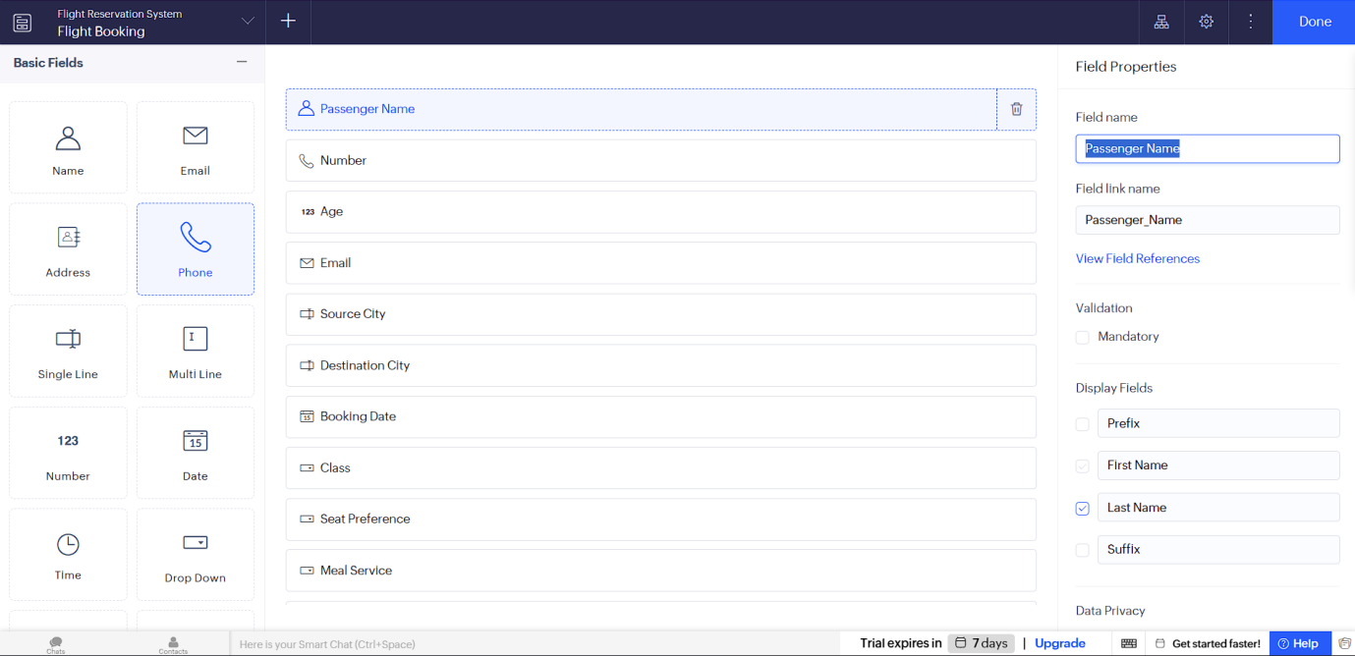
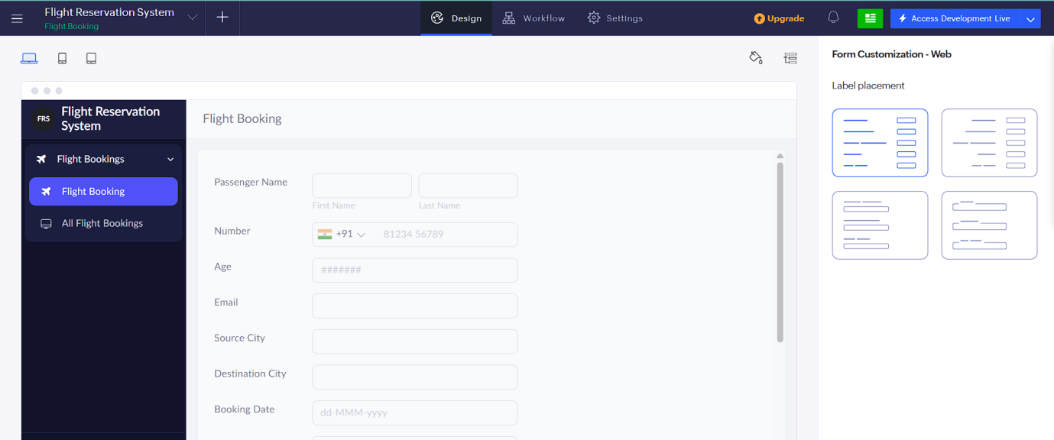
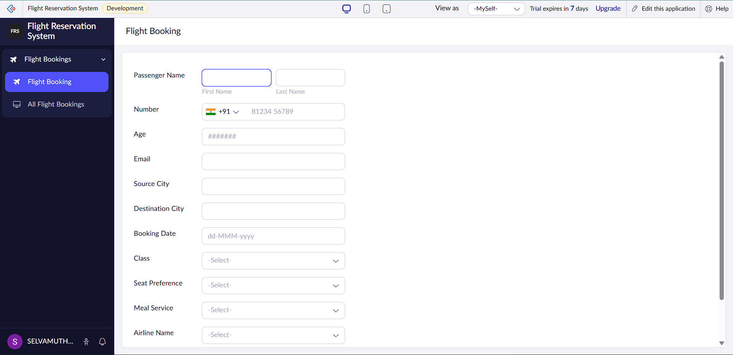

RESULT: A cloud-based Flight Reservation System is successfully implemented as a SaaS application, enabling users to book and manage flight reservations online.

